SIGNALS 2
Program 3: SIGCHLD - Child Process Signal
#include <stdio.h>
#include <signal.h>
#include <unistd.h>
#include <sys/wait.h>
void handle_sigchld(int sig) {
printf("SIGCHLD received: Child has terminated.\n");
}
int main() {
signal(SIGCHLD, handle_sigchld);
pid_t pid = fork();
if (pid == 0) {
// Child
printf("Child is running ... \n");
sleep(3);
printf("Child is terminating ... \n");
} else {
// Parent
printf("Parent is waiting ... \n");
wait(NULL);
printf("Parent finished.\n");
}
return 0;
}

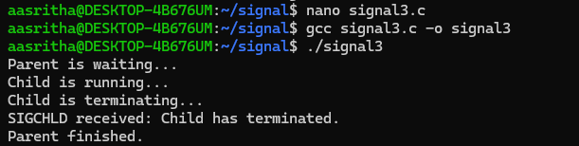
Program 4 - SIGPIPE - Broken Pipe
#include <stdio.h>
#include <unistd.h>
int main() {
int fd[2];
pipe(fd);
close(fd[0]); // Close read end
printf("Writing to pipe ... \n");
write(fd[1], "Hello", 5);
printf("Write completed.\n");
return 0;
}
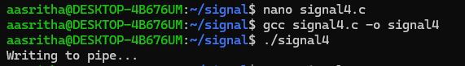
Program 5 - kill() program
#include <stdio.h>
#include <signal.h>
#include <unistd.h>
#include <sys/wait.h>
void handler(int sig) {
printf("Child received SIGUSR1\n");
}
int main() {
pid_t pid = fork();
if (pid == 0) {
// Child
signal(SIGUSR1, handler);
printf("Child waiting ... \n");
while (1) {
sleep(1);
}
} else {
// Parent
sleep(2);
printf("Parent sending signal ... \n");
kill(pid, SIGUSR1);
sleep(2);
kill(pid, SIGTERM);
wait(NULL);
}
return 0;
}
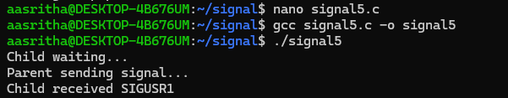

Program 6 - SIGABRT — Abort
#include <stdio.h>
#include <stdlib.h>
int main() {
printf("Program started\n");
abort();
printf("Program ended\n");
return 0;
}
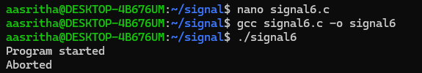
Program 7: SIGSEGV - Invalid Memory Access
#include <stdio.h>
int main() {
int *p = NULL;
printf("Before error\n");
*p = 10; // Invalid memory access
printf("After error\n");
return 0;
}
